Machine Learning Steps

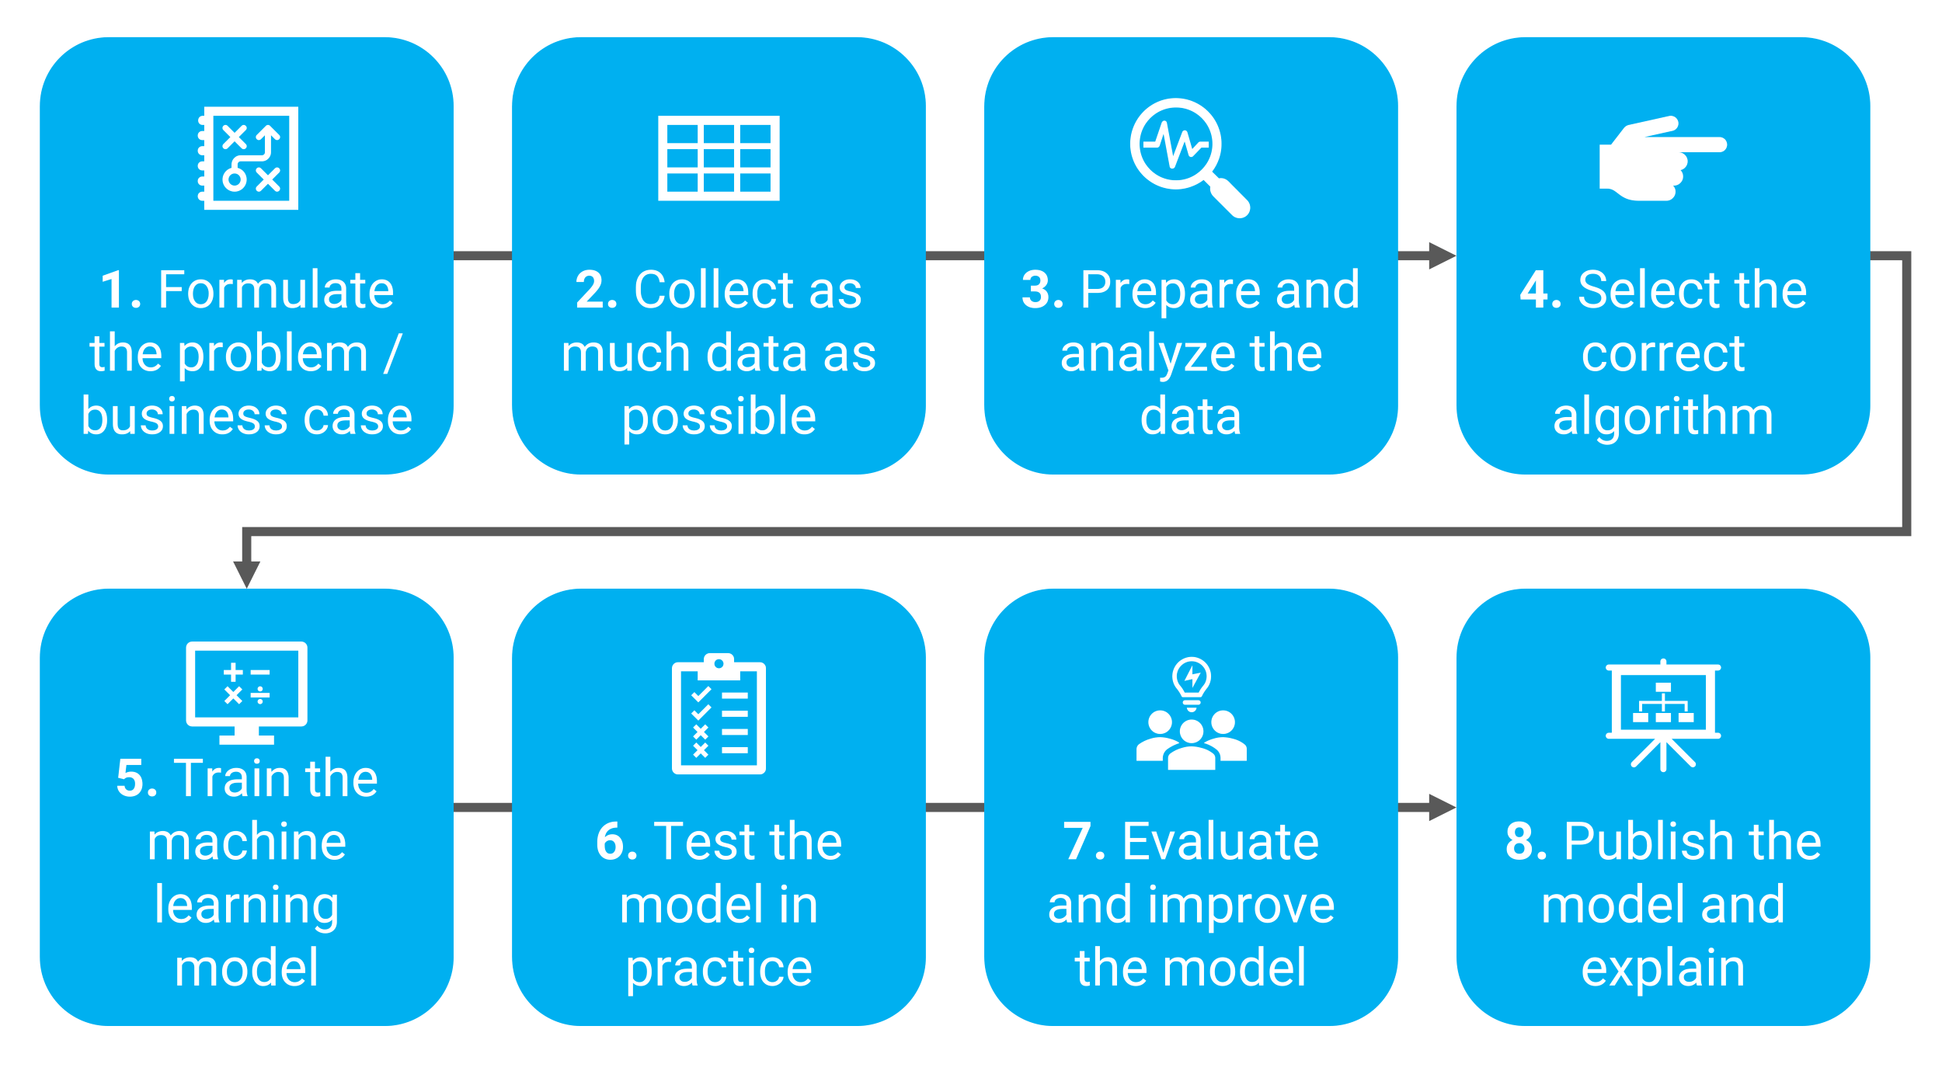

Machine Learning Data Set (e.g 100/100):

Training Set (e.g 80/100)

Validation Set (e.g 10/100)

Test Set (e.g 10/100)

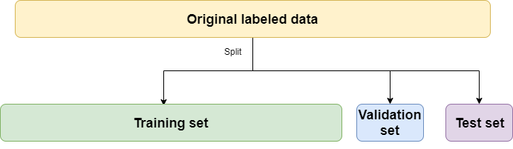

Machine Learning Model Evaluation

Under-fitting

Appropriate-fitting

Over-fitting

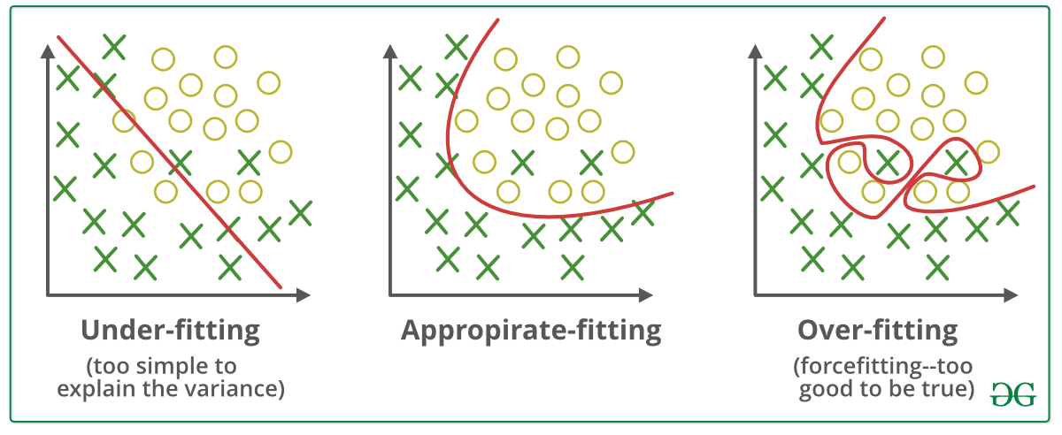

Machine Learning model – **approximation** of function

Training Error – for Training Set

Validation Error – for Validation Set

Test Error – for Test Set­

Generalization Error- for unseen/new data

Machine Learning Inference – the unseen/new data input X1, X2, X3… put into the model to infer the outcome Y

Machine Learning Prediction - predicts the Y of the property with the given features X1, X2, X3…

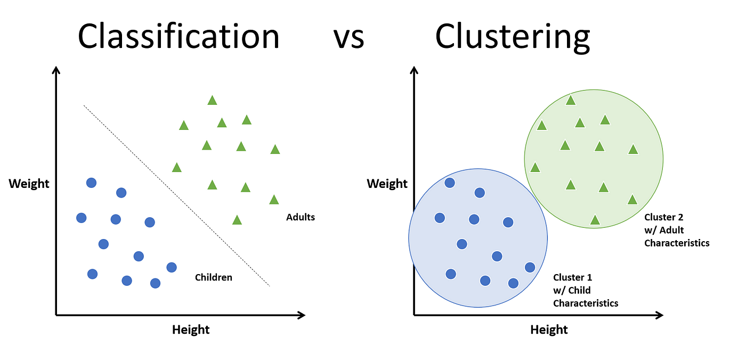

Machine learning data normalization - Transforms all data into standardized data format

pip install pandas

pip install matplotlib

pip install scikit-learn

**pip install tensorflow**

pip install seaborn

A Data frame is a two-dimensional data structure, i.e., data is aligned in a tabular fashion in rows and columns. Pandas DataFrame consists of three principal components, the data, rows, and columns.

<https://pandas.pydata.org/>

<https://mlu-explain.github.io/linear-regression/>

2D line

3D plane

## 4D hyperplane

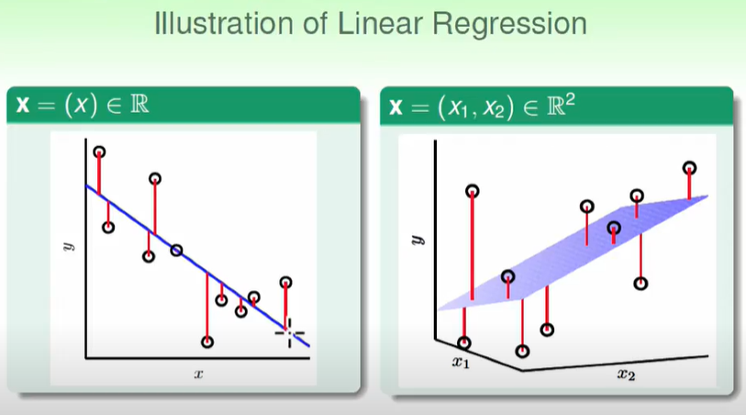

Linear Regression, Housing dataset, scikit-learn

SVM – Classification, iris dataset, scikit-learn

Artificial Neural network

MNIST dataset

<https://en.wikipedia.org/wiki/MNIST_database>

Programming

def function(x):

if x==1:

return y

elif x ==2:

return y

Machine Learning

Train a XX Classifier

Tensorflow 2 – Computational Graph in Tensor

keras – neural network model

Artificial Neural networks <–> human brain

Activation Function Sigmod(), RELu()…etc

-> add non-linearity-> move like human brain

List my_list = [0, 1, 2, 3, ‘str’ ]

# data any type

Numpy

np.ndarray[0,1,2,3] # all data is the same type

np.ndarray.shape (row, col, isBlackColor)

(28,28,1)

Train a classifier with 10 outputs=\= write a function

Model=function **approximation**

model = Model()

model.fit() # train neutral neutrons

model. Predict() # input X to predict Y

Neuron activation function use ReLU or sigmoid()

User defined number of output =10 classifications

output layer activation function softmax

to converts the final layer outputs into probabilities

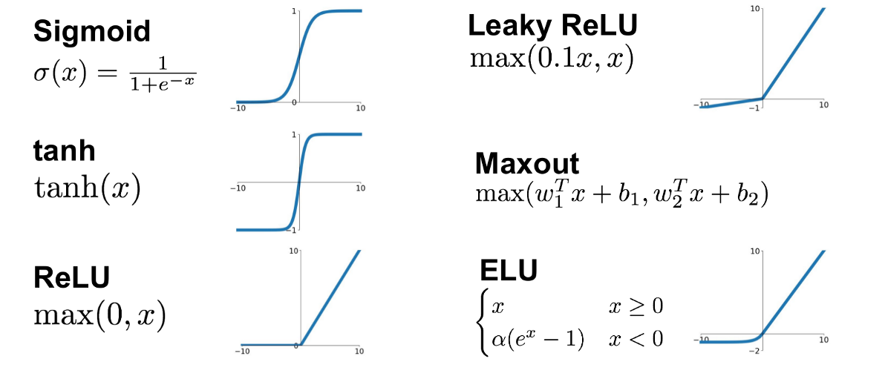

forward propagation in neural network

train model/fit: cost function/loss function -> Error minimization

entropy in machine learning : measures the level of uncertainty in a given dataset.

# what is a neural network? | Deep learning chapter 1

<https://www.youtube.com/watch?v=aircAruvnKk>

<https://www.youtube.com/watch?v=IHZwWFHWa-w>

<https://www.analyticsvidhya.com/blog/2021/10/feed-forward-neural-networks-intuition-on-forward-propagation/>

1 machine learning model as objective function **approximation**

2 activation function to behave a non-linear human neuron

3 output layer activation function to convert output to Probability Function

4 Cost Function is the relationship between error and testing data during model training

<https://www.allerin.com/blog/3-types-of-neural-networks-that-ai-uses>

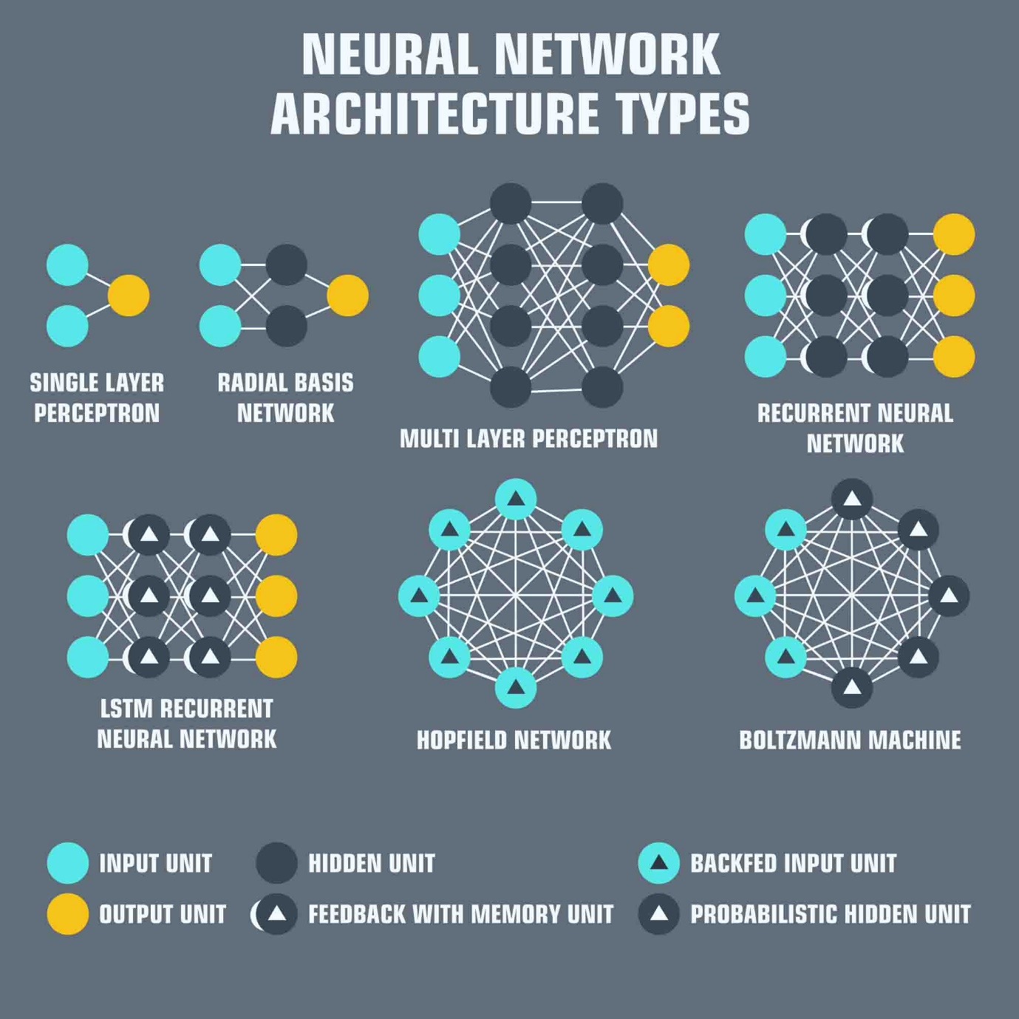

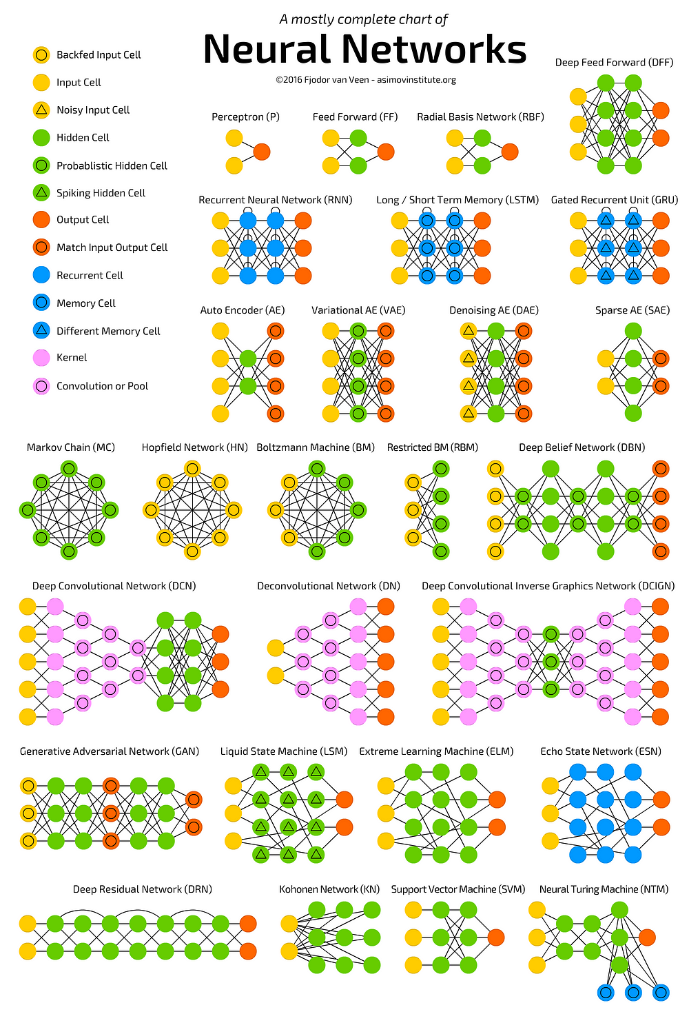

https://www.deep-mind.org/2023/03/26/the-universal-approximation-theorem/